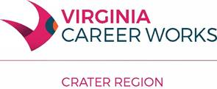**Crater Regional**

**Workforce Development Board**

22 W. Washington St.

Petersburg, VA 23803

Mainline: 804-862-6155

Office: 804.835.5100

Fax: 804.732.6668

May 6, 2022

SUBJECT: Notice of Intent to Award

This letter serves as notice pursuant to the Request for Proposals for WIOA Title I Adult, Dislocated Worker, and Youth Service Provider released by the Crater Regional Workforce Development Board (CRWDB) on March 17, 2022 of an intent to award the aforementioned provision of services to Eckerd Connects.

The bidder listed above received the evaluation team’s highest score. An executed contract has not yet occurred and this notice does NOT constitute the formation of a contract between the CRWDB and Eckerd Connects. The CRWDB reserves the right to cancel this Notice of Intent to Award at any time prior to the execution of a written contract.

Sincerely,



Tabitha S. Taylor, MA, CWDP

Executive Director

Crater Regional Workforce Development Board